Wan Tse Shuen
Bachelor of Social Science, Singapore Management University, 2026 (est.)
Cumulative GPA: 3.60 / 4.00 (Jan 2024)
Mobile: 89094248 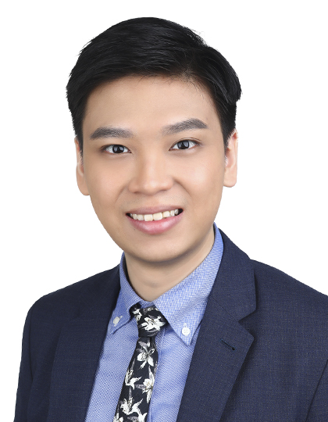
tswan.2022@socsc.smu.edu.sg

RELEVANT WORK EXPERIENCE

Promises Healthcare, Visions by Promises | Intern
May 2023 – Aug 2023
- Assisted with development and execution of behavioural addictions intensive recovery program (Gaming focused)
- Acted as observer/support leader in groups held at Visions including;
  - Alcoholics Anonymous (AA)
  - Continuing Care (behavioural & substance addictions)
  - Gaming addiction
- Repetitive transcranial magnetic stimulation (rTMS) technician with Neuronetic’s Neurostar platform. Provided treatment for a wide range of clients diagnosed with depressive, anxiety and obsessive-compulsive disorders
- Provided administrative and secretarial support for Director of Visions, Andy Leach, in preparation for panel held by United Women Singapore – Boys Empowered Summit
- Invited to attend Asia Pacific Behavioural & Addictions Medicine Conference 2024 with Visions by Promises.

Vive Active Joo Chiat | Concierge
Jan 2024 – Present
- Administrative class support and facilitating on-boarding of new members

Active Fitness | Front of House
Jul 2022 – Nov 2023
- Accounting for class attendance and providing live responses to member enquiries
- Facilitating on-boarding of new members

NASCANS@Ngee Ann Primary | Student Care Mentor
Dec 2021 – Jul 2022
- Preparation and execution of after-school activities for a group of 25 students aged 9 and 10 including; administering meals, extracurricular programs and enrichment activities
- Planned holiday activities for upper primary students, including a short course on music theory

EDUCATION AND QUALIFICATIONS

Singapore Management University – School of Social Sciences
Psychology Major
Aug 2022 – May 2026 (expected)
- Cumulative GPA: 3.60 / 4.00

rTMS Certified Technician (Neurostar)
Mar 2023
- Completed Neuronetics clinical training program for TMS Therapy with Neurostar platform

EXTRA-CURRICULAR ACTIVITIES

Research Assistant | Dawn Labs @ SMU
Jan 2024 – Present
- Assisting Professor Andree Hartanto’s graduate students with running experiments at Dawn Labs

Teaching Assistant | Big Questions
Aug 2023 – Dec 2023
- Provided administrative and class support for Professor Matthew Hammerton

Research Assistant
Sept 2023 – Nov 2023
- Assisted Professor Matthew Hammerton with literature review relating to prebunking, debunking and inoculation in preparation for conference panel

Director of Operations and Finance | SOSS Freshmen Orientation
May 2023 – Aug 2023
- Oversaw department in managing administrative matters including outreach/registration of incoming freshmen, sourcing/procuring camp merchandise and connecting facilitators with their assigned freshmen
- Managed all finance and budgeting related matters

SMU Athletics (Recreational Running)
Aug 2022 – Present
- Member of biweekly running club

Deputy Secretary General | North American Model United Nations
Jan 2017 – Jan 2018
- Overall in-charge for academic related matters; designing, developing and execution of offered committees (General Assembly, Specialised Agencies, Crisis and Joint-Crisis).
- Managed branch directors and staff hiring/training of over 200 conference staff
- Held previous positions as moderator, crisis manager and crisis coordinator

COMMUNITY SERVICE

GIC Sparks and Smiles Study Grant
Aug 2023
- Leadership & community engagement program jointly offered by GIC and Beyond Social Services
- Assigned door-knocking role to interview and procure essential information for communities served by Beyond Social Services at Whampoa, Lavendar and North Bridge Road areas.

